



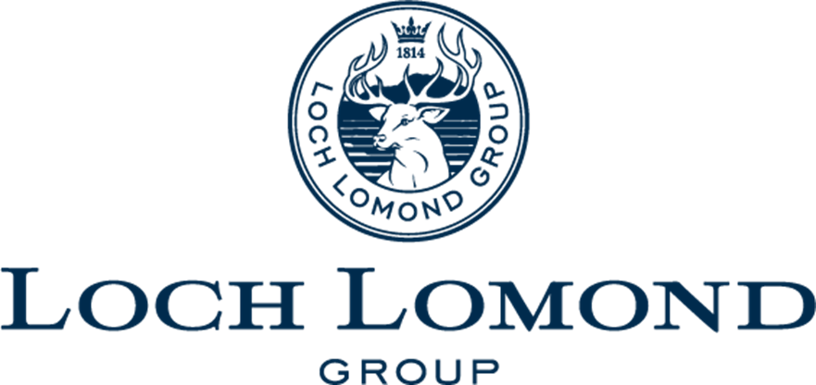
Finance Analyst – Corporate & Capital
POSITION PROFILE

Contents
The Company 3
The Role 4
The Individual 5
Remuneration & Recruitment Process 6



Loch Lomond Group is an independent premium drinks producer with a global reach in 120 countries worldwide and an enviable reputation for some of the most exciting and innovative brands in the premium drinks sector.

Our goal is to create and build amazing brands with quality and premium products at the heart of them and bring them to the world through exciting partnerships and through our global network of distributors.

Loch Lomond Single Malt whisky has roots back to 1814 and achieves global recognition through its ongoing partnership with the Oldest Golf tournament in the world – The Open Championship and a real commitment to quality recognised through winning “Most Awarded Distillery” at the internationally renowned San Francisco wines and spirits competition.

Glen Scotia (established in 1832) is one of the few remaining distilleries in the Campbeltown region and the winner of “Best Whisky in the World” in 2021 for its multi-award winning expression Glen Scotia 25 Year Old and won distillery of the year in the same year – the only whisky brand to have ever achieved this.

Littlemill established in 1772 is the oldest licensed distillery in the world and although sadly now silent, Loch Lomond Group hold the last few precious casks and releases small quantities annually. Working with artists and craftsmen around the world to produce breathtaking prestige releases to honour the legacy of one of the most important distilleries in Scotland. As well as historically established brands, Loch Lomond Group has launched Spearhead and Noble rebel brands which have a different take on Whisky creating more contemporary brands to appeal to different consumers.

Alongside the whisky portfolio, Glens Vodka with its sponsorship of the Scottish Professional Football League, is growing strongly in the UK market and innovating in the vodka market to continue growing its consumer appeal. Loch Lomond Group’s premium Gin brand - Ben Lomond Gin has achieved a Double Gold and 98/100 for its core Gin Expression at the San Francisco International Wines and Spirits competition in its first year of entry and working with influencers to grow brand awareness.

Our portfolio has grown again recently with the introduction of Champagne Piaff which is a proud sponsor of the Longines Champions Show Jumping Tour and has a burgeoning reputation for its Champagne quality picking up prestigious listings in some of the best bars, restaurants and hotels.

Job Title: Finance Analyst – Corporate & Capital

Reports to: Finance Manager – Corporate & Capital

Location: Mainly Alexandria – some travel to Catrine required. Office based

Position Overview
The position has been created to strengthen the company’s financial performance and controls around the operational elements of the business as it continues to grow. The post-holder will work as part of a small but highly performing finance team and will be working closely with the operation teams focused mainly on Capital & Group Overhead Cost Centres. This position will require an individual who is hungry to learn and take on additional responsibility.

The organisation represents an excellent opportunity for a motivated individual who wants to work in a high-growth, drinks business. In addition, the business will provide a firm career platform with good opportunities for personal and professional development, as well as the mandate to shape and define how the role evolves.

Study Support is available for the right candidate.

The main duties and responsibilities will involve:
- Support the Finance Manager - Capital & Corporate in producing monthly financial reporting & management accounts for the group
- Assist with the monthly accounting processes on assigned cost centres or areas of expenditure including; preparation of accruals, preparation of monthly management accounts, budgeting and supporting budget holders with forecasting
- Produce daily control reconciliations and monthly balance sheet reconciliations
- Support the Finance Manager - Capital & Corporate in providing accurate and value-adding financial analysis to enable informed decision-making on anything involving costs or efficiency
- Work with the wider finance team in the development of systems, controls and processes, ensuring a robust environment as the business continues to grow
- Develop technical awareness and expertise in all areas of finance (including stock, credit control, accounts payable, taxation and statutory accounting) to enable the support and delivery of financial reporting, including some training of non-finance teams and new joiners
- Assist in the development and ongoing maintenance of the Group Finance Controls, ensuring documentation remains up to date and reflects the changing business needs and regulatory environment
- Ad hoc project work as and when required

The position incorporates a wide range of responsibilities requiring a confident individual with strong interpersonal skills. Ideally, the individual will have experience of working in an accountancy role and be a self-starter to ensure the successful growth of this role.

It is likely that the successful candidate will be a recent accountancy graduate, who is looking to continue their studies towards their professional accountancy qualification (ACCA/CIMA) alongside this role where they can gain practical, hands on experience. The role encompasses a broad range of duties and therefore requires an individual who is prepared to be flexible to the business’ needs.

The key candidate requirements for the position include:
- Holds a revelant university degree in Accounting/Finance, and/or has experience in an accounting role
- High level of accuracy and attention to detail
- Must be hungry to learn and take on new tasks and responsibilities
- Ability to work under pressure, manage deadlines and prioritise effectively
- Energy, drive, tenacity, professionalism and commitment
- Strong IT skills, and excellent MS Excel skills are essential
- Ability to work well in a team, but also capable of taking ownership of the delivery of specific tasks

- Strong written and verbal communication skills

Salary: £Competitive + Annual Bonus

Additional Benefits: Up to 15% bonus

Pension with 5% EE & ER contribution

25 days annual leave with the ability to buy/sell 5 days leave, plus 9 statutory holidays

There is scope for the right candidates to be given study support toward professional finance or HR/payroll qualification

Flex Friday – finish at 2 pm on a Friday (subject to a manager's approval)

Westfield Health Cashback plan – money back on a range of healthcare treatments plus online GP and doctor second opinion service

Access to discounts at several large retailers, restaurants and online hotel booking sites

Discounted gym memberships

Confidential counselling line for mental health issues

Access to advice on legal issues via a confidential support line
Subsidised flu jabs



Gillian O’Neil, CFO Services
T: 07432 482 882
E: gillianoneil@rutherfordcross.com

The Recruitment Process
- Applications should be sent to Gillian O’Neil at Rutherford Cross:
gillianoneil@rutherfordcross.com

