


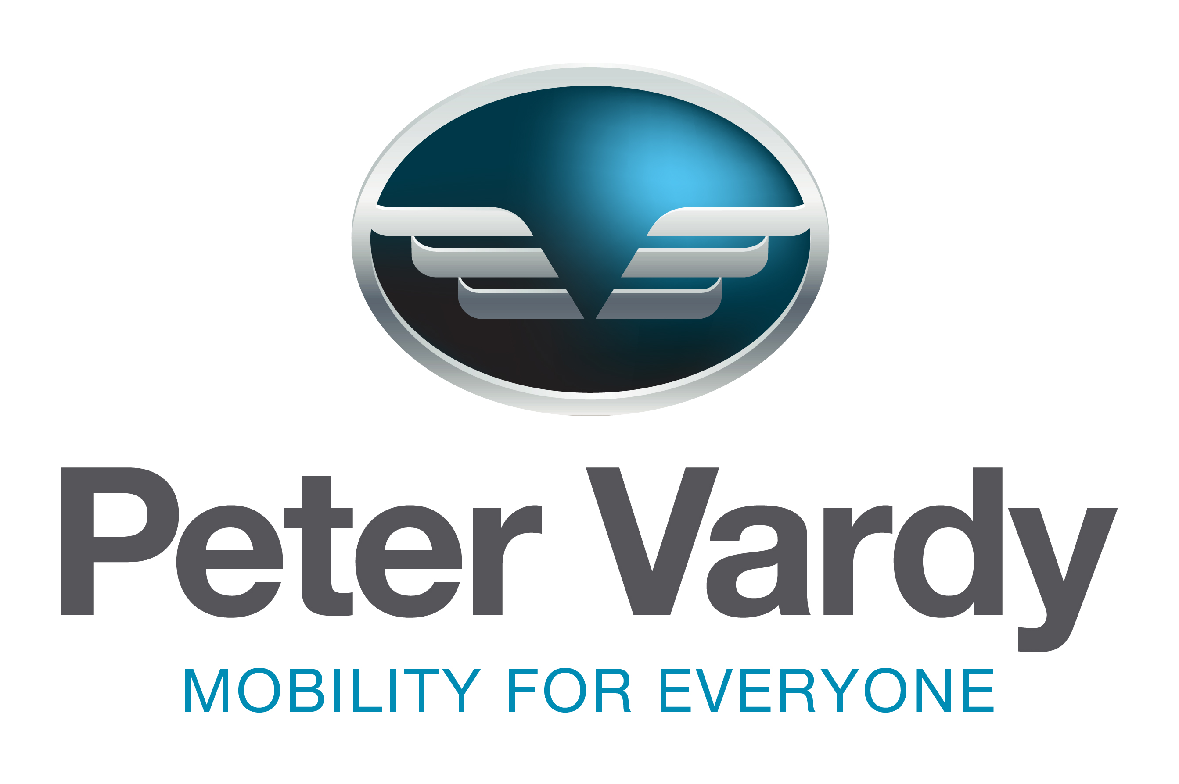
POSITION PROFILE

Finance Manager

The Company 3
The Role 4
The Individual 6
Remuneration and Recruitment Process 8
Appendix 1: Benefits 9


Peter Vardy Group is a dynamic organisation which stretches across motor retail, car finance, leasing and rental and has a focus on a world class guest experience in-store and online. The business’s 2030 strategy maps out ambitious growth plans with the guest experience at heart.

PVL was established in July 2006 by Peter Vardy who had a vision to create a world-class motor retail business like no other. The Group is renowned for its innovative approach to colleague and customer engagement which features at the heart of the business model and PVL truly believe that a satisfied and passionate team will deliver the best possible customer experience.

With a turnover in excess of £500m and staff numbers exceeding 1,200, the Group has plans for significant yet measured future growth. The Group has focused its business activities within the Scottish Region and has fourteen award-winning dealership locations throughout Scotland with a Head Office based in Motherwell. The Group also consists of a finance brokerage firm, CarMoney, and has also launched two new businesses, Peter Vardy Leasing and Peter Vardy Rental, to ensure PVL lead the way with changing consumer behaviour.

PVL is a fast-moving retail company that places substantial reliance on quality financial reporting and is, therefore, focused on robust, accurate and timely financial management and reporting to drive the operational performance throughout the Group.

The aim for PVL is to be the Best Place to Work and the Best Place to Buy, winning awards in both areas in recent years. The purpose is “We Sell to Give” and 10% of the group’s annual profits go directly to the Peter Vardy Foundation which support children and young people across the UK and worldwide. In 2020 PVL also launched a new start-up charity GenZ Leaders, an online leadership programme for all school children in Scotland.

Job Title: Finance Manager

Reports to: Finance Director & Managing Director

Direct Reports: 1x Accounts Assistant

Location: Head offices based in Motherwell (Hybrid working model)



This is a newly created role as a direct result of recent business growth. The purpose of this role is to support the Managing Director, Finance Director and departmental teams to meet agreed business goals and ensure the smooth running of the finance department. The successful candidate will be expected to perform the following responsibilities:

- Ensure that financial controls are followed throughout the division
- Take the lead in the development of business plans in conjunction with the Finance Director and Managing Director
- Accurately prepare monthly accounts, forecast and trends to meet group deadlines
- Carry out detailed VAT checks monthly
- Complete and submit quarterly VAT returns
- Ensure payments of salary and wages to dealership personnel is carried out timely and accurately and that all records, either by law or by company are maintained with no errors
- Maintain relevant records to ensure year end corporation tax schedule and P11D schedule may be completed accurately and timeously
- Ensure purchase ledger, credit control, cash and banking procedures are adhered to
- Liaise with internal and external auditors over the final / interim audits and produce year-end financial details as required
- Ensure finance team receive monthly coaching and development, to help identify future individual and departmental needs and carry out regular 1-2-1’s
- Establish yourself as a key member of the management team directly supporting the Managing Director and Finance Director
- Continuously monitor and look to make improvements to procedures and controls
- Other Ad-hoc duties as required

The Finance Manager role requires a driven and motivated individual that is used to working in a fast-paced working environment. We are particularly keen to speak management accountants or those with a business partnering background. An interest in the motor trade would also be advantageous, although not required. A summary of the key candidate requirements are as follows:

Qualifications & Experience:
- Fully, part or ‘Qualified By Experience’ Accountant (CIMA/ACCA/ICAS or equivalent)
- Experience of optimising business performance in a similar, fast-paced organisation.
- Experience of maintaining excellent stakeholder relationships
- Previous experience of Xero desirable

Skills, Knowledge & Abilities:
- Strong Microsoft Office skills
- Strong organisational skills
- Excellent Excel and numeration skills
- Ability to prioritise a busy workload
- Excellent communication skills, both written and orally
- Able to work on their own initiative

Other Key Characteristics & Behaviours:
- High levels of drive and personal commitment to achieving success
- Remains calm when under pressure
- Results-driven and respect for deadlines
- Pro-active individual
- Strong team player
- Passion to learn and develop

Peter Vardy believe that a company's ethos and character is determined by the values, characteristics and principles that they set. Therefore, it is important that Peter Vardy employees live by the following
Peter Vardy Key Characteristics:
- Audacity – willing to take risks and being proactive
- Unity – help motivate others, work together as part of a team
- Generosity – seek to help and support others
- Humility – 100% effort into achieving goals and objectives

- Tenacity – being open, honest, organised and accountable

Package: Up to £50k (Dependent On Experience) + Annual Bonus + Company Car

Company Pension: Employer contribution: 3% employer, 5% employee

Holiday Entitlement: 30 days plus additional days for time in service (pro-rata)

Bonus / Share Scheme: See benefits package Appendix 1



Gillian O’Neil, CFO Services
T: 07432 482 882
E: gillianoneil@rutherfordcross.com

The Recruitment Process
- Initial interviews are with our retained advisors at Rutherford Cross
- Second stages will be with the Finance Director and Head of Operational Finance
- Applications should be sent to Gillian O’Neil at Rutherford Cross: gillianoneil@rutherfordcross.com

Financial Wellbeing
- Best pay scheme for best performance
- PV Cares – Employee discounts and Lease car options
- World class incentives
- 30 days holiday plus additional for long service (pro-rata)

Mental Wellbeing
- Mental Health MOT’s
- Dedicated In house counselling team.
- Mental Health First Aid Training (Manager)
- Life Assurance
- Flexible working

Physical Wellbeing
- Covid health and safety measures
- Access to PV Wellness and Fitness App
- Cycle Scheme

Spiritual Wellbeing
- Company Chaplin support
- Giving back programme
- Mentor Programme
- Colleague Events – Family events, Children’s Christmas party, Ball

